**EECS 3431 Camera User Manual**

**Nisha Shlaymoon**

**Michael Founk**

**Instructions:**

**Zoom Feature:**

To control the zoom on the first quadrant shown below, simply hold the mouse button and move the mouse **up** to **zoom in** or **down** to **zoom out**.

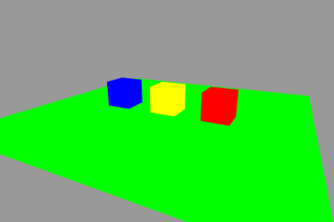

**Camera Parameters:**

To control the camera on any of the other quadrants, simply hold the mouse button down near the point you wish to move, whether be it **lookAt, lookFrom** or **lookUp.** Then, move the mouse as you wish within the quadrants.